

BILBO GOLF CLASSIC
IN MEMORY OF BILLY KILPATRICK, BILL KILPATRICK, AND BILL REED
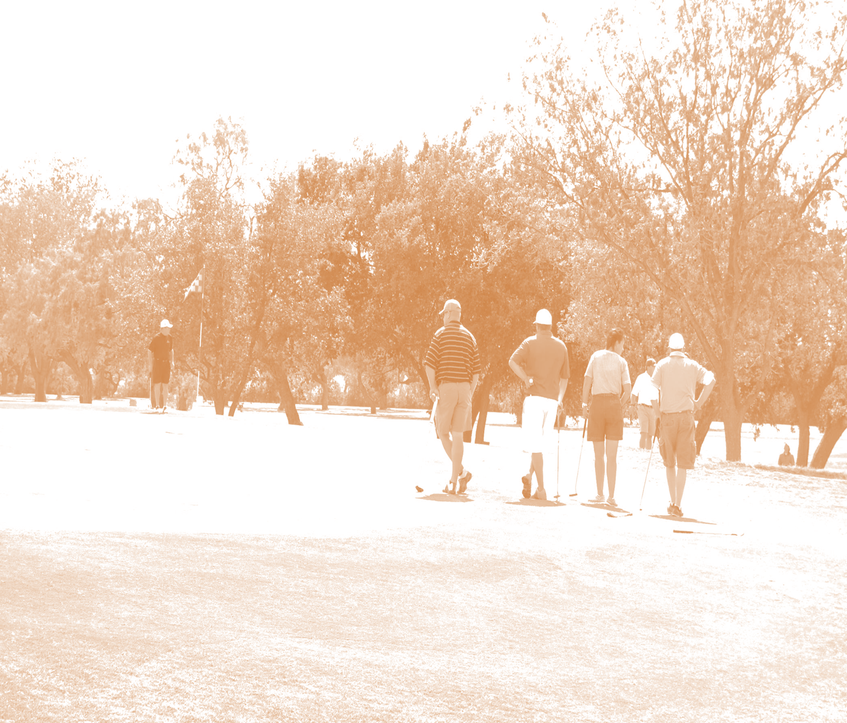
Dear Friends,

It’s time for the 43rd Annual Bilbo Golf Classic! Thank you for continuing to be a part of this fun tournament! It’s only successful because of people like you!

The Bilbo Committee is committed to continuing the balancing of a great pay back to the players and providing a great fundraiser to the charity. The Bilbo will be held on Saturday, May 4th at Maxwell Golf Course - Abilene, Texas. Spots will be very limited again this year and you are encouraged to enter early. DO NOT WAIT TO ENTER!

YOU MUST return your completed sponsor form with payment by 5 pm Friday, April 19th. There will be a hard cutoff this year on entries to allow time for signs to be ordered. Please note that this year individual entries will not be taken until after April 15th with only Sponsor Entries until that date. A minimum sponsor entry will be required to enter through April 15th. If there are spots available individual entries will be taken during the week of the 15th. This year there will not be website entries so please pay by check or by credit card by filling out the form attached to send with your entry. For questions, please contact Scott Anderson at 325-437-1852 or by email at scott.anderson@newhorizonsinc.com.

Proceeds from the auction and tournament will benefit The Bill Reed, Bill Kilpatrick, and Billy Kilpatrick Scholarship Fund, and the Abilene Chapter of the March of Dimes.

Thank you again for being part of Bilbo and supporting a wonderful cause!

Sincerely,
The Bilbo Committee


BILBO GOLF CLASSIC
Schedule of Events

Note: Teams will be computer drawn by independent person or firm. We cannot guarantee any tee times or make any changes after draw. If you enter tournament, please be prepared to play on Saturday. There will be no Sunday rounds.

April 15th Individual Entries will be taken if spots are available. No individual entries will be taken prior to this date.

April 19th Deadline for all entries into tournament – All golfer information is due.
Note: All Sponsor’s golfer entry spots must be filled by April 19th, or unfilled spots will be for forfeited to the Bilbo Committee.

May 3rd 8:30am Sponsor Two-Man Scramble – MAXWELL GOLF COURSE

6:00pm Pre-Tournament Party – Player Auction
Held at The Zone
3112 South 27th St
Abilene, TX 79605
Bring your spouse/significant other/friends/random people and come meet your teammates Teams will be posted and Auction will begin at 6:30pm. PLEASE ARRIVE TIMELY AS WE ARE GOING TO LIMIT THE AUCTION ITEMS AND WE WILL BE SELLING TEAMS EARLIER. Don’t miss buying your team! All teams will be sold live and must be paid for at the auction or your team will be sold at check-in on a first come basis. Food and Beer will be available.
May 4th Four Person Scramble-Computer Drawn Teams
MAXWELL GOLF COURSE – Abilene, Texas
7:30 a.m. Tournament desk opens, pick up carts. Everyone must register.
8:30 a.m. Shotgun start.

Silver Bullet Shootout
Immediately after Award Presentation with 2 Shootout groups:
Bill Reed - Silver Bullet Shootout will be the first 10 Lowest Handicap Players Entered
Bill Kilpatrick – Oilfield Shootout (Silver and above sponsors)
Billy Kilpatrick – Cods Shootout (Silver and above sponsors)
ALL PLAYERS WILL PLAY SATURDAY
Food and beverages will be available for purchase on the golf course.
For more information, please call:
Scott Anderson at 325-437-1852 please leave a message if no answer and your call will be returned.

SPONSORSHIP FORM
***Name as you want it to appear on all signs.***

Please Print Clearly

**TOURNAMENT ENTRY LEVELS **

INDIVIDUAL ENTRY (After April 15th -If Available) $200 ________

MEDALLION $250 ________
- One Tournament Entry
- Name on Sponsor Board

BRONZE $500 ________
- All Medallion Benefits plus
- Course Sign

SILVER – (One Sponsor Tournament Entry) $800 ________
- All Bronze Benefits Plus
- One Tournament Entry (2 Total)
- One Shootout Entry

GOLD $1,000 ________
- All Silver Benefits Plus
- One Tournament Entry (3 Total)
- One Shootout Entry (2 Total)
- One Course Sign (2 Total)

PLATINUM (One Sponsor Tournament Entry (2-Total) $1,500 ________
- All Gold Benefits Plus
- Two Tournament Entries (5 Total)

DIAMOND (One Sponsor Tournament Entry (3-Total) $2,000 ________
- All Platinum Benefits Plus
- One Tournament Entry (6 Total)
- One Shootout Entry (3 Total)
- One Banner
- Reserved Table at Auction and Personal Recognition

DOUBLE DIAMOND (One Sponsor Tournament Entry (4-Total) $2,500 ________
- All Diamond Benefits Plus
- Two Tournament Entries (8 Total)

BILBO HEADLINER (One Sponsor Tournament Entry (5-Total) $5,000 ________
- All Double Diamond Benefits Plus
- Two Tournament Entries (10 Total)
- Two Course Signs (4 Total)
- One Banner (2 Total)
- One Shootout Entry (4 Total)
- Prime Location Reserved Table at Auction (2 Total)
- SEE BACK FOR REQUIRED PAYMENT INFORMATION
PAYMENT INFORMATION

If By Check:

Payable to Bilbo Golf Classic

Mail Entries to:
Attn: Scott Anderson
Bilbo Golf Classic
1626 Pemelton Drive
Abilene, Texas 79601

If By Credit Card: (Please Print Clearly)

Name on card _____________________________________________

Card Number _____________________________________________

Expiration date ______________

CVV Code _________

Zip Code _______________________

Phone Number _______________________

REQUIRED GOLFER INFORMATION (Please Print Clearly)
(USE EXTRA PAGES IF MORE THAN 6)
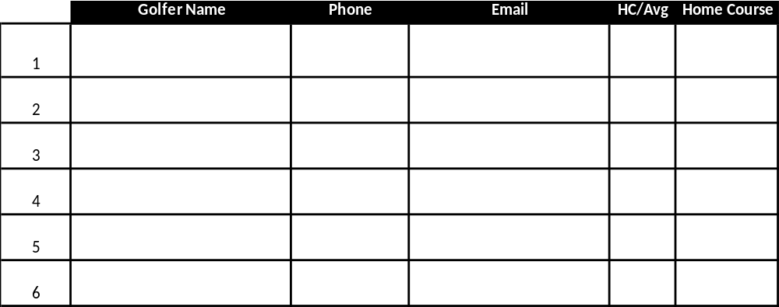

SHOOTOUT PLAYERS (Silver or higher sponsors only)

Player 1________________________ Player 2_______________________

SPONSOR TWO MAN TEAMS (Silver or higher sponsors only)

Team 1_____________________________ Team 2____________________________

Team 3_____________________________ Team 4____________________________

